Recurring Tasks
S/N | Task | Classification | Rationale
1 | Revise internship notes | Just me | It requires my critical thinking to do. Though AI can generate questions, notes are purely handwritten. Thus, using AI will increase revision time
2 | Learning about Hospital Management Systems | Collaborate with AI | AI has access to lots of resources, is good at teaching too and I’ll be asking Qs
3 | Learn Arabic w/ Duolingo | Just me | I need to use my critical thinking to do the actual learning. AI will not benefit here
4 | Research content ideas for my clothing brand | Delegate to AI with review | AI is good at researching and generating ideas which will save me time
5 | Review my friend’s research paper and give feedback | Collaborate with AI | I still need to verify the facts used, give my own insights and any fix mistakes by AI
6 | Make a LinkedIn post about my career progress | Delegate to AI with review | It’s a generation task where with enough context, AI will do it very well but still need to keep my voice
7 | Document and upload my deliverables (assignments/projects) on GitHub | Collaborate with AI | AI will speed up documentation while I focus on pushing to GitHub
8 | Journal any interesting events within my week | Collaborate with AI | It can generate the final entry whilst I give it my brain dumped ideas and thoughts
9 | Compose weekly Jumaat Mubarak messages | Fully automate | AI is good at drafting messages which will save time
10 | Assist my sisters with their assignments | Just me | This needs my critical thinking and physical presence to teach them
11 | Plan and prioritize my day | Just me | This needs my critical thinking as I’m the one who knows the weightings to my tasks each day

My Audit Tasks (With success definitions)
- Make a LinkedIn post about my career progress
At most 250 words long
A first line hook that attracts people - the first line is one sentence and makes sense without the rest of the post
Have a clear post structure that can easily be inferred by readers
Show at least a result
Ends with an open-ended question
- Research content ideas on TikTok for my clothing brand
Exactly 10 ideas (or 7 to 10), each with a theme
Each idea clearly explains what its video entails
Each idea should have a credible source i.e., a trend, a video or an account
- Document and upload my deliverables (assignments/projects) on GitHub
A well-defined outline for the documentation
Plain-language explanation of what I did, understandable with little technical knowledge
At least one clearly defined result
Claude Configured Project
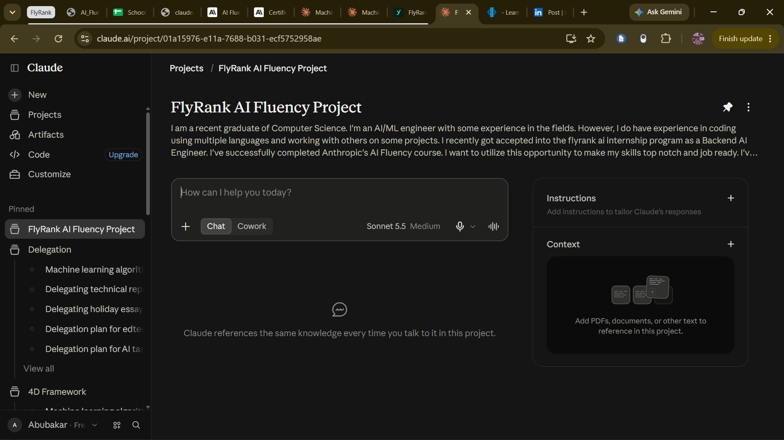

Academy enrollment
